Software Development Proposal Template

Created by:

​​Frederick E. ​Marcelo – ISKA Development

Prepared for:

TPCM Coop

CONTENT

**Introduction and Cover Letter**

​​[Sender.FirstName] ​[Sender.LastName]

​[Sender. Company]​

​​[Sender.StreetAddress] ​[Sender.City] ​[Sender.State] ​[Sender.PostalCode]​

​​2023-06-08​

​​[Client.FirstName] ​[Client.LastName]

​[Client.Company]​

​​[Client.StreetAddress] ​[Client.City] ​[Client.State] ​[Client.PostalCode]​

Dear (Mr/Ms) ​[Client.LastName],

Thank you for meeting with us to discuss your company’s software project requirements. Attached is our detailed software proposal for your consideration and approval.

At ISKA Development we know that creating client-oriented software takes a mixture of technical excellence and clear communication.

Our firm hires only the very best to ensure you receive both. We know that every client is unique, so we strive to deliver an individual, innovative, and affordable proposal every time, following through with an outstanding delivery that is both on time and within budget.

We also pride ourselves on our after-sales client-care including our guarantees, staff training, and onsite and offsite support.

Finally, we realize that you are very busy and wanted to thank you in advance for your time spent reviewing our business proposal.

Yours Truly,

Frederick E. Marcelo

At ISKA Development

Executive Summary

The modern business world has been irrevocably shaped by technology, and for good reason. Many long-standing problems in industries like (Client.Industry) can be solved with the right program. It’s not enough to simply use pre-existing solutions, however. Companies like ​[Client.Company], who take the next step and work to produce innovative solutions, are the businesses that have taken the lead over and over again.

To help your company achieve (Client.Mission.Statement), we will do all of the following:

Create (Main focus of the business proposal)

After a thorough but efficient preparation period, our team will create (focus of the proposal).

We will build this with a focus on (Client Problem 1), (Client Problem 2), and (Client Problem 3). The resulting software will achieve:

(Goal 1)

(Goal 2)

(Goal 3)

Develop (Additional tools needed for the solution)

Through clear communication and regular meetings with your planning team, we will develop (additional tools or programs).

We will take industry trends and your unique needs into consideration to ensure that (the tools mentioned above) will fit your goals and serve your businesses.

Integrate (Unique or external tools)

In coordination with (client's partners/on-site IT), we will take care to integrate (important industry tools like social media or specialized software) with this solution. This will help maintain the services and systems you already use, smoothing the transition period.

(Method of completing the project proposal)

We will (achieve goals listed above) by utilizing (your business processes) and (your team's organizational style).

These processes allow us to (USP of your business).

As a result, our team members will complete this project in (time proposed).

As accepted by Company

TPMC Cooperative

​[Client.FirstName] ​[Client.LastName]

Project Overview

At ​ISKA Development, we (Mission statement). As such, we at ​[Sender.Company] have put together a plan to develop (Subject of proposal) for ​[Client.Company]. This software solution will (Purpose of the product), (Additional Benefit 1), and (Additional Benefit 2).

Hardware and Software Technology Requirements

The software and hardware you will need to complete the proposal.

To provide the solution ​[Client.Company] needs, we will use:

Operating System:

(Name of the required operating system)

Language:

(Language name)

Hardware:

(Basic hardware requirements)

(Servers, if needed)

(Specialized hardware)

Software:

(Basic software needed)

(Specialized software needed)

​

Obstacles

(Risk 1)

(Risk 2)

Technical Obstacles

(Risk 1)

(Risk 2)

Industry and Market Risks

(Risk 1)

(Risk 2)

Budgetary Risks

(Risk 1)

(Risk 2)

Milestones and Reporting

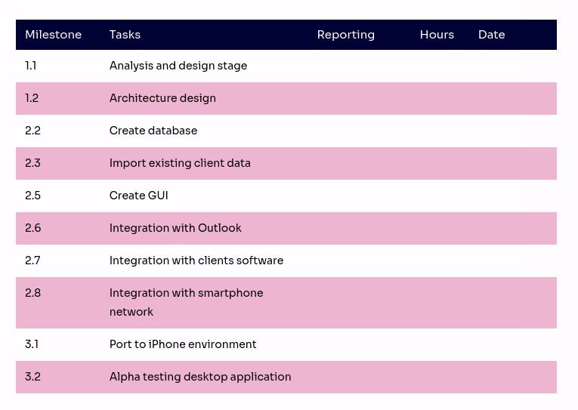​

​

​

Deployment

Launching new software requires focus and dedication. To ensure that your launch goes as smoothly as possible, we will (describe launch procedures, including any assistance your organization provides during the process).

Documentation

We want to make sure you never have any questions about the product after launch. To guarantee you understand your new software, we put together:

(Documentation Type 1)

(Documentation Type 2)

(Documentation Type 3)

If you have any questions, please let us know and we will clarify with additional documentation.

Support

Describe your standard support agreement.

At ​[Sender.Company], we pride ourselves on our customer service. If you ever have problems with your software, our software developers will (Customer.ServicePolicy)

Testing

We pride ourselves on always providing our clients with the best possible product. To make this happen, we will (Testing Procedure 1). We then (Testing Procedure 2). Finally, after the launch of the product, we study what is working and what isn’t, then tweak things until you are happy with the final result.

Warranty

Include your standard warranty information here, or use the text below after review from your legal team.

We offer a (Time period) day warranty from the date of (acceptance of our software proposal/completion of the project). During the warranty period, ​[Sender.Company] will take the necessary steps to rectify any software malfunctions or operation failures that occur and ensure that the software operates as intended. Even after the expiration of the warranty, we remain open to questions and concerns if you need further assistance.

Training

Describe how you will train your potential client on their new software.

To ensure that all users understand your new software, we (describe training procedure).

Pricing and Payment Terms

Pricing and payment should always come at the end of the proposal. These are the terms your client will agree to should they sign the document, so be certain that your math is sound and your numbers are accurate. This is where you list any potential discounts or deals, along with the cost of the project as a whole and how funds will be distributed.

Our fee for seeing the project through from start to completion will be (Fee). You can pay via credit card, bank transfer, and PayPal. The breakdown of each aspect of the project is as follows:

Software development, calculated at an hourly rate of (Rate): (Amount) Launch and support, calculated at an hourly rate of (Rate2): (Amount2)

Documentation, calculated at (Calculation Method): (Amount3)

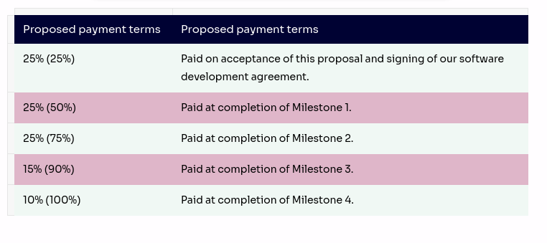

Contact Us

You can get in touch with us in any of the below ways:

By Phone

​[Sender.Phone]​

By Email

​[Sender.Email]​

On our website

​[Sender.Website]​

By post

​[Sender.StreetAddress] ​[Sender.City] ​[Sender.State] ​[Sender.PostalCode]​

If you would like to proceed with our proposal then you can sign the first page and return a copy to us by fax, email or post. In any case please feel free to call us to discuss the quote, request more information or for any other reason.

We look forward to hearing from you soon!

​

​

​​[Sender.Company]

​[Sender.FirstName] ​[Sender.LastName]​

​​[Client.Company]

​[Client.FirstName] ​[Client.LastName]

Content

FILLABLE FIELDS FOR

Start typing name or email

BLOCKS